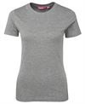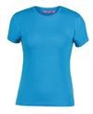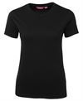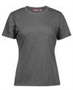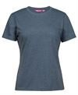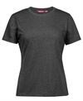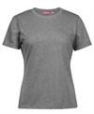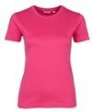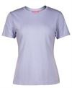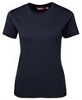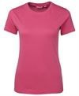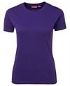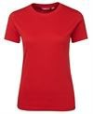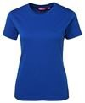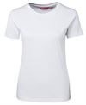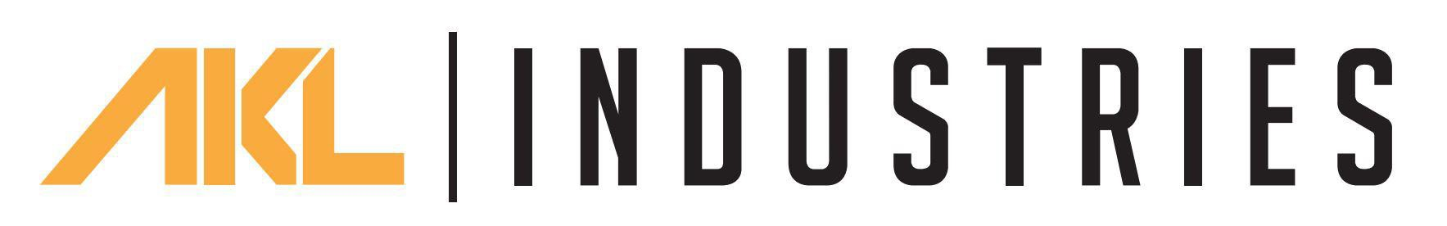
Available Colours:
Navy (UPF
50+)
Pink (UPF
50+)
Purple (UPF
50+)
Red (UPF 50+)
Royal (UPF
50+)
White (UPF
50+)

LADIES TEE
1LHT
A colour to fit you.
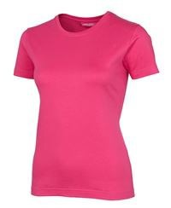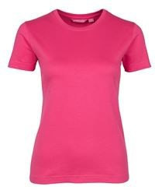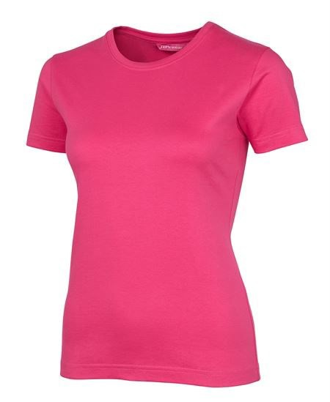

13% Marle  (UPF 50+) | Aqua (UPF  50+) | Black (UPF  50+) | Charcoal  Marle (UPF | Denim Marle  (UPF 50+) | Graphite  Marle (UPF | Grey Marle  (UPF 50+) | Hot Pink (UPF  50+) | Lilac (UPF 30)
 |  |  | 50+) |  | 50+)

Details |  | Sizing
> 100% Cotton for 100% comfort |  | LADIES | 8 | 10 | 12 | 14 | 16 | 18 | 20
> *13% marle: Cotton/Viscose |  | BUST | 43.5 | 46 | 48.5 | 51 | 53.5 | 56 | 58.5
   | *Denim, Graphite: Cotton/Polyester  *Charcoal, Grey Marle: Polyester/Cotton | SP LENGTH | 62.5 64.5 |  | 66.5 | 68.5 | 70.5 | 72.5 | 73.5
 | 165gsm ring spun Jersey knit fabric
 | JB's shape staying Elastane rib crew neck
 | Vertical side seams minimise twist in the tee’s body
 | Complies with Standard AS/NZS 4399:2017 for UPF Protection
 | Urban Fit

